**Lab Mid CCN**

**Question no 01**

1. Network Topology Diagram– (4 marks)

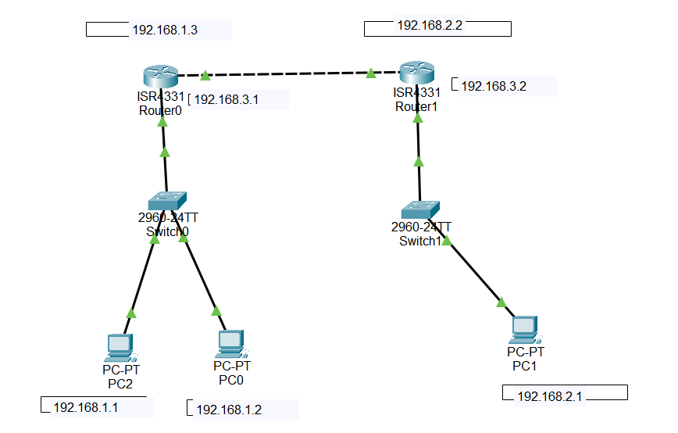

1. VLAN Configuration Commands (Switch1 & Switch2) – (4 marks)

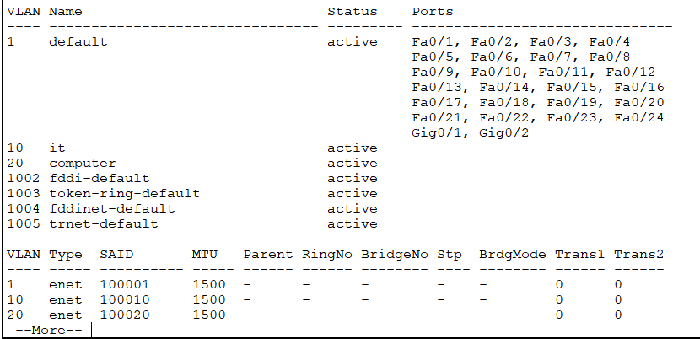

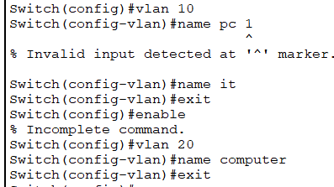

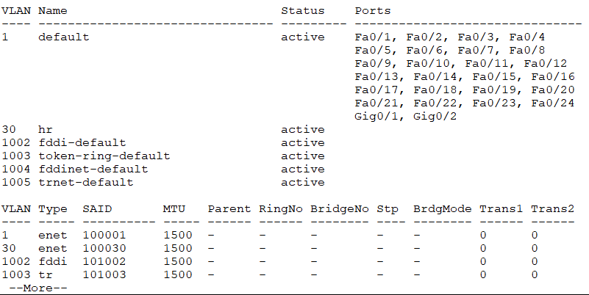

3. Router Configuration – (4 marks)

o Sub-interfaces for Router

o IP addressing

|  |  |  |
| --- | --- | --- |
| Network 1 | Network 2 | Network 3 |
| Pc 0 = 192.168.1.2  Pc 2 = 192.168.1.2  Router =192.168.1.3 | Router 0=192.168.3.1  Router 1=192.168.3.2 | Pc 1 = 192.168.2.1  Router =192.168.2.2 |

o Static routes between routers

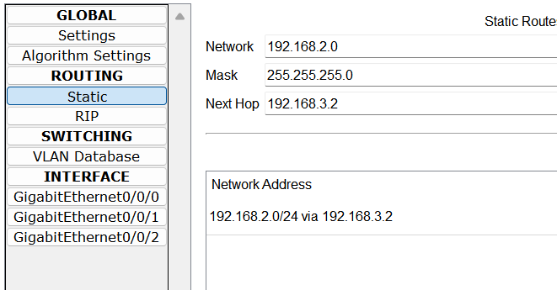

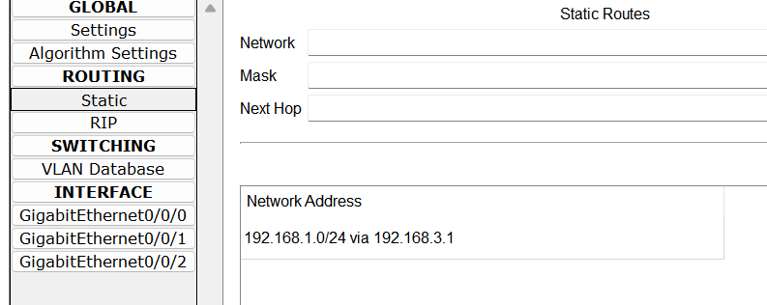

Ping Test Screenshots – (4 marks)

o Between VLANs on the same switch

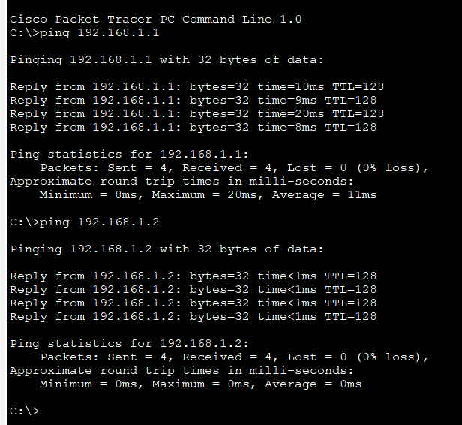

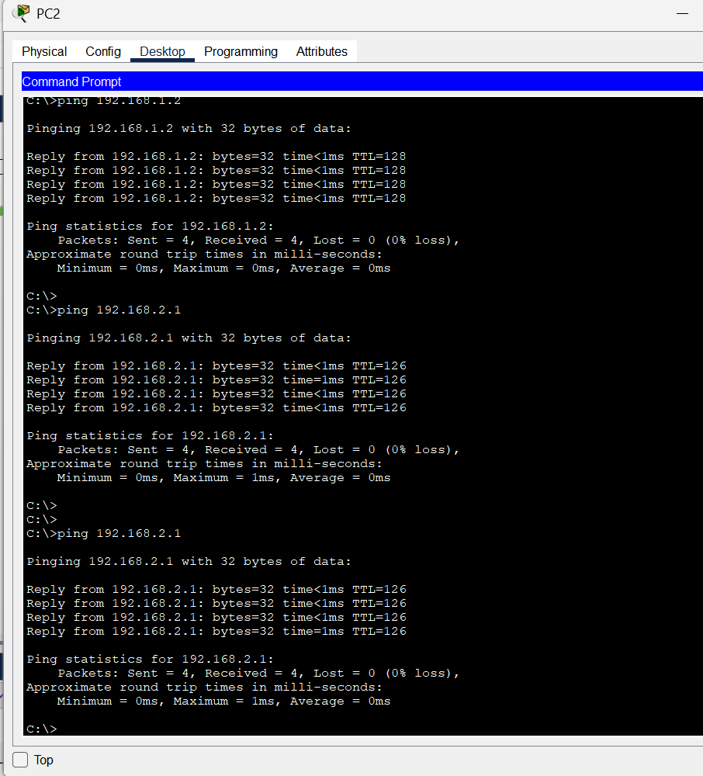

o Across different switches

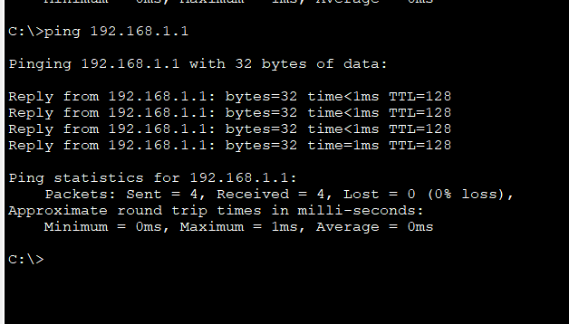

. Correct IP Addressing & Subnetting – (4 marks)